**Step 1 : Check the docker0 bridge**

ip a

**Step 2 : Install the bridge utils**

yum install bridge-utils

Note : Brctl replaces older [brcfg](http://manned.org/brcfg/456d1fb2) tool which has only modest capabilities to configure bridge. As said, it is part of bridge-utils package and it's capabilities encompass creation, deletion and configuration of multiple bridges on one computer

**Step 3 : List interfaces on Docker0**

brctl show docker0

**Step 4 : Run a new container**

docker run -itd ubuntu:14.04 /bin/bash

**Step 5 : Login to the container**

docker exec -it f565bf38cf19 /bin/bash

**Step 6 : Verify the route for the container**

root@f565bf38cf19:/# route –n

**Step 7 : Verify the interfaces**

brctl show docker0

Note : Once you launch new container a virtual Ethernet port on docker0 switch gets created

**Step 8 : from your docker OS login-root**

Note : You can know the host name of container from below commands and also DNS server ip address

cat /var/lib/docker/containers/0f4ea7ba2e814169377263918a9cb027f72f0295c45dc96f8661d0630501bc27/hosts

cat /var/lib/docker/containers/0f4ea7ba2e814169377263918a9cb027f72f0295c45dc96f8661d0630501bc27/hostname

cat /var/lib/docker/containers/0f4ea7ba2e814169377263918a9cb027f72f0295c45dc96f8661d0630501bc27/resolv.conf

cat /var/lib/docker/containers/0f4ea7ba2e814169377263918a9cb027f72f0295c45dc96f8661d0630501bc27/config.v2.json

**Step 9 : Run a new container with port mapping**

docker run -d -p 5001:8080 tomcat:7

docker run -d -p 5002:8080 tomcat:7

**Step 10 : verify the port mapping**

docker port 09bd9a867ae4

**Step 11 : List the docker networks**

docker network ls

**Step 12 : Inspect details about your bridge docker0**

docker network inspect bridge

The Engine automatically creates a Subnet and Gateway to the network. The docker run command automatically adds new containers to this network.

**Step 13 : Inspect details about your Host only networking**

docker network inspect host

**Step 14 : Create a two network**

docker network create --driver bridge network01

docker network create --driver bridge network02

**Step 15 : List available networks and verify new network is created**

**Step 16 : Creating 2 new container in the new network created**

docker run --network=network01 -itd --name=container01 ubuntu:14.04

docker run --network=network02 -itd --name=container02 ubuntu:14.04

**Step 17 : List your running containers**

docker ps

**Step 18 : Inspect both networks**

docker network inspect network01

docker network inspect network02

docker exec -it container01 /bin/bash

root@760ea20aaaff:/# ping 172.19.0.2

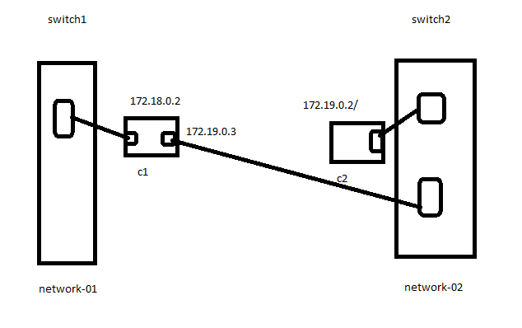

**Attach your container 01 to netowrk01**

docker network connect network02 container01

docker exec -it container01 /bin/bash

**root@8f6d85f7b54f:/# ping 172.19.0.2**

